**Hands-on Documentation: Exercise 3 – JUnit Assertions**

**Title:**

Using Assertions in JUnit to Validate Test Outcomes

**Objective:**

To validate the correctness of code using different **JUnit assertions** such as equality, truth, nullity checks.

**Tools & Technologies Used:**

* **IDE**: IntelliJ IDEA
* **Framework**: JUnit 4.13.2
* **Java Version**: JDK 1.8+
* **Build Tool**: Maven

**Steps Performed:**

**Step 1: Create new Project**

**Step 2: Created a New Test Class**

Class: AssertionsTest.java  
Package: default (or can be added under a custom one)

**Step 3: Implemented the Following Assertions:**

@Test

public void testAssertions() {

assertEquals(5, 2 + 3); // Validates equality

assertTrue(5 > 3); // Checks if condition is true

assertFalse(5 < 3); // Checks if condition is false

assertNull(null); // Checks if value is null

assertNotNull(new Object()); // Ensures value is not null

}

**Step 4: Executed the Test**

* Test ran successfully.
* All assertions passed.
* Verified correct test behavior.
* Output : 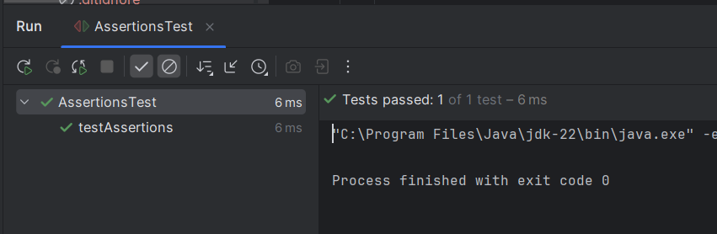

**Conclusion:**

* Demonstrated usage of key JUnit assertions.
* These assertions are essential for verifying expected behavior in unit tests.
* The project is now ready to use more advanced assertions and exception handling in tests.